**VISVESVARAYA TECHNOLOGICAL UNIVERSITY**

JNANA SANGAMA, BELAGAVI – 590 018



**A Report on**

***ART GALLERY***

*Submitted in partial fulfillment of the requirements as a part of the DBMS Laboratory for the award of degree of*

**Bachelor of Engineering**

**in**

**Information Science and Engineering**

Submitted by

**AKSHATHA.NT HARSHITHA.N**

**1RN16IS013 1RN16IS037**

**Faculty Incharge**

**R Rajkumar**

**Asst.Professor**

**Dept. of ISE, RNSIT**



**Department of Information Science and Engineering**

**RNS Institute of Technology**

Channasandra, Dr. Vishnuvardhan Road, RR Nagar Post,

Bengaluru – 560 098

2018 – 2019

**RNS Institute of Technology**

Channasandra, Dr.Vishnuvardhan Road, RR Nagar Post,

Bengaluru – 560 098

**DEPARTMENT OF INFORMATION SCIENCE & ENGINEERING**



**CERTIFICATE**

This is to certify that the mini project report entitled ***ART GALLERY*** has been successfully completedby **AKSHATHA N T** and **HARSHITHA N** bearingUSN **1RN16IS013** and **1RN16IS037**, presently V semester student of **RNS Institute of Technology** in partial fulfillment of the requirements as a part of the DBMS Laboratory for the award of the degree***Bachelor of Engineering in Information Science and Engineering*** under**Visvesvaraya Technological University, Belagavi**during academic year 2018 – 2019. It is certified that all corrections/suggestions indicated for Internal Assessment have been incorporated in the report deposited in the departmental library. The mini project report has been approved as it satisfies the academic requirements as a part of DBMS Laboratory for the said degree.

**Mr. R Rajkumar Dr. M V Sudhamani**

Faculty Incharge Professor and HOD

Assistant Professor

**External Viva**

**Name of the Examiners Signature with date**



**ABSTRACT**

Art Gallery is an application used to sell art works of artists irrespective of their nationality, gender and other narrow considerations. The art and decor items are bought by the art gallery where visitors can view and buy them. The art works are either hosted for auction or sold for a fixed price. The art gallery displays a wide range of products from paintings to artifacts. Each customer has the right to purchase an art work and participate in auctions by submitting their bids. After each valid payment, the art work will be shipped within 15 days if the buyer chooses for shipment.

The aim is to automate its existing manual system by the help of computerized equipments and full-fledged computer software, fulfilling their requirements, so that their valuable information can be stored for longer period with easy accessing and manipulation of the same. Basically the project describes how to manage the gallery for good performance and better services.

**ACKNOWLEDGMENT**

The fulfillment and rapture that go with the fruitful finishing of any assignment would be inadequate without the specifying the people who made it conceivable, whose steady direction and support delegated the endeavors with success.

We would like to profoundly thank **Management** of **RNS Institute of Technology** for providing such a healthy environment to carry out this Project work.

We would like to thank our beloved Director **Dr. H N Shivashankar** for his confidence feeling words and support for providing facilities throughout the course.

We would like to express my thanks to our Principal **Dr. M K Venkatesha** for his support and inspired me towards the attainment of knowledge.

We wish to place on record my words of gratitude to, **Dr. M V Sudhamani,** Professor and Head of the Department, Information Science and Engineering, for being the enzyme and master mind behind my Project work.

We would like to express my profound and cordial gratitude to my Faculty incharge, **Mr.R Rajkumar**, Assistant Professor, Department of Information Science and Engineering for their valuable guidance, constructive comments and continuous encouragement throughout the Project work.

We would like to express my profound and cordial gratitude to my guide, **Mrs. Kusuma R**, Assistant Professor, Department of Information Science and Engineering for their valuable guidance in preparing Project report.

We would like to thank all other teaching and non-teaching staff of Information Science & Engineering who have directly or indirectly helped me to carry out the project work.

And lastly, we would hereby acknowledge and thank our parents who have been a source of inspiration and also instrumental in carrying out this Project work.

**AKSHATHA.N.T HARSHITHA.N**

**1RN16IS013 1RN16IS037**

**TABLE OF CONTENTS**

**Sl.No Chapter Name Page No.** ABSTRACT i

ACKNOWLEDGEMENT ii

TABLE OF CONTENT iii

LIST OF ACRONYMS v

LIST OF FIGURES iv

1. INTRODUCTION

1.1 Background 1

1.2 Introduction to Art Gallery 2

2. ER DIAGRAM 3

2.1 E-R Diagram Relationships Description 3

3. RELATIONAL SCHEMA DIAGRAM 5

3.1 General Constraints 6

3.2 Definition Of Tables 6

4. SYSTEM DESIGN

4.1 Tables 8

5. IMPLEMENTATION

5.1 Software Used 11

5.2 Snapshots 13

6. APPLICATIONS 21

7. CONCLUSION 22

8. FUTURE ENHANCEMENTS 22

REFERENCES 23

**LIST OF FIGURES**

**Sl.No Name of Figure Page No.**

Fig.2.1 ER Diagram of Art Gallery 3

Fig.3.1 Relational Schema of Art Gallery 5

Fig.5.1 Login Form 13

Fig.5.2 Main Menu 13

Fig.5.3 View Orders 14

Fig.5.4 Take Orders 14

Fig.5.5 Search Orders 15

Fig.5.6 Show Search Order 15

Fig.5.7 Add Product 16

Fig.5.8 List Of Products 16

Fig.5.9 Transport Details 17

Fig.5.10 Event List 17

Fig.5.11 Delete Event 18

Fig.5.12 New Event 18

Fig.5.13 Auction List 19

Fig.5.14 Worker Data Login 19

Fig.5.15 Worker List 20

Fig.5.16 Add Worker 20

**ABBREVIATIONS**

BOOTP - Bootstrap Protocol

BGP - Border Gateway Protocol

CMC - C Model Checker

DNS - Domain Name Service

DHCP - Dynamic Host Control Protocol

DART - Directed Automated Random Testing

D3S - Debugging Deployed Distributed Systems

DNSSD - DNS Service Discovery

D-ITG - Distributed Internet Traffic Generator

DNV - Declarative Network Verifier

IETF - Internet Engineering Task Force

IOT - Interoperability Testing

LLVM - Low Level Virtual Machine

MPE-SE - Multiple Packet Exchange – Symbolic Execution

PPP - Pont-to-Point Protocol

PC - Path Condition

RFC - Request for Comments

SAGE - Scalable, Automated Guided Execution

SM - Symbolic Map

SPE-SE - Single Packet Exchange – Symbolic Execution

TRAM - Tree Based Reliable Multicast

mDNS - MulicastDN

**Chapter 1**

**INTRODUCTION**

**1.1 Background**

A **database** is an organized collection of [data](https://en.wikipedia.org/wiki/Data_(computing)), generally stored and accessed electronically from a computer system. Where databases are more complex they are often developed using formal [design and modeling](https://en.wikipedia.org/wiki/Database#Design_and_modeling) techniques.

The [database management system](https://en.wikipedia.org/wiki/Database#Database_management_system) (DBMS) is the [software](https://en.wikipedia.org/wiki/Software) that interacts with [end users](https://en.wikipedia.org/wiki/End_user), applications, the database itself to capture and analyze the data and provides facilities to administer the database. The sum total of the database, the DBMS and the associated applications can be referred to as a "database system". Often the term "database" is also used to loosely refer to any of the DBMS, the database system or an application associated with the database. The DBMS manages three important things: the data, the database [engine](https://whatis.techtarget.com/definition/engine) that allows data to be accessed, locked and modified and the database [schema](https://searchsqlserver.techtarget.com/definition/schema), which defines the database’s logical structure. These three foundational elements help provide [concurrency](https://searchoracle.techtarget.com/definition/concurrent-processing), security, [data integrity](https://searchdatacenter.techtarget.com/definition/integrity) and uniform administration procedures. Typical database administration tasks supported by the DBMS include [change management](https://searchcio.techtarget.com/definition/change-management), performance monitoring/tuning and [backup](https://searchdatabackup.techtarget.com/definition/backup) and [recovery](https://searchdisasterrecovery.techtarget.com/definition/data-recovery). Many database management systems are also responsible for automated [rollbacks](https://searchsqlserver.techtarget.com/definition/rollback), restarts and recovery as well as the [logging](https://whatis.techtarget.com/definition/log-log-file) and [auditing](https://searchcio.techtarget.com/definition/audit-trail) of activity.

**1.2 Introduction to Art Gallery**

Art gallery is the place where the arts and artifacts can be displayed for the visitor’s view. People also comment on the arts that artists exhibit so that there will be some scope of improvement of the arts that is displayed. Sometimes it will be difficult to maintain the details of the artists and their paintings details through the pen paper method. Art gallery management is an application that allows the owners to maintain the details of the artists and their works with great ease.

The artists can have their paintings, artifacts, decors and many other forms of art that can be displayed in the art gallery. Some of the art galleries would have artifacts paintings of some years ago. But at some point of time if the artist’s details are required, then this application would come in handy. Details of any artist and there products, sales made by the gallery, events hosted, all of it can be obtained with ease in just one mouse click. Some of the features that it can be include in this system application.

* **Orders**: Billing of the products purchased by the customers visiting the art gallery.
* **Artists and artifacts database management:**The details of the artists like name, address, products, contact can be stored easily through this application.
* **Events**: The details about the events and auction that will be hosted.
* **Transportation**: The details of the products that has to be transported to the customer.
* **Sales details**: The details of the sales that have taken place on a particular day can be obtained in this system.

**Chapter 2**

**ER DIAGRAM**

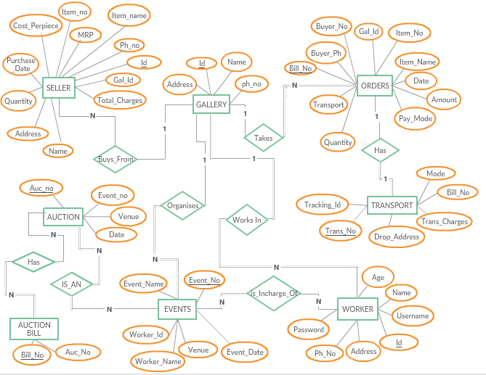

**Fig.2.1: ER diagram of Art Gallery**

The E-R Diagram in Figure 2.1 describes entities, attributes and relationships.

* Entity types like GALLERY and ORDERS are in rectangular boxes.
* Relationships like HAS and WORKS_IN are in diamond boxes, attached to entity types with straight lines.
* Attributes are shown in ovals, each attached by a straight line to entity or relationship type.
* Key attributes (like ID) are underlined.
* Component attributes of a composite attribute are attached to oval representing it.

**2.1 E-R Diagram Relationships Description**

1. **SELLER: GALLERY** is of cardinality N: 1 as one gallery can have more than one seller and therefore connected via ‘Buys_From’ relationship. There is no total participation of both entities as:

• A gallery can exist without belonging to a seller.

• A seller can exist without gallery that belongs to him/her.

1. **GALLERY: ORDERS** is of cardinality 1: N as 1 gallery can have N number of orders that are taken by it. They are connected via the relationship ‘Takes’. There is total participation of ORDERS and GALLERY has partial participation as:

• An order cannot exist without having a particular gallery to take it.

• A gallery can exist without orders being taken.

1. **ORDERS: TRANSPORT** is of cardinality 1: 1 as 1 order can be transported only once. Also, each transportation detail belongs to specific product. They are connected via the relationship ‘Has’. There is total participation of TRANSPORT and partial participation of ORDERS as:

• An order may or may not require transportation.

• A transportation cannot exist without an order being placed.

1. **EVENTS: AUCTION** is of cardinality N: N as events will have N auctions and gallery has N events. Also each auction is an event. They are connected vis the relationship ‘IS_AN’. There is total participation of AUCTION and partial participation of EVENTS as:

• An event can exist without having an auction being conducted.

• An auction is an event.

1. **GALLERY: WORKER** is of cardinality 1: N as 1 gallery can have only N workers working. Also, each worker’s information is distinct by their id. They are connected via relationship ‘Works In’. There is total participation of WORKER and partial participation of GALLERY as:

• A gallery can exist without workers working for the gallery.

• A worker does not exist without the existence of a gallery to work for.

1. **WORKER: EVENTS** is of cardinality N: N as N number of workers work for N no of events that take place in gallery. They are connected by relationship ‘Is_Incharge_of’. There is total participation of both entities as:

• A worker cannot exist without working for any of the events.

• An event cannot take place without any workers working for it.

1. **GALLERY: EVENTS** is of cardinality 1: N as 1 gallery conducts N number of events. They are connected via relationship ‘Organises’. There is total participation of EVENTS and partial participation of GALERY as:

• A gallery can exist without organising events.

• An event cannot take place without it being organized by a gallery.

1. **AUCTION: AUCTION BILL** is of cardinality N: N as N auctions an have N number of bills of the items that are purchased by the bidders. The relationship is ‘Has’. There is total participation of AUCTION BILL and partial participation of AUCTION entity as:

• An auction bill cannot exist without an auction being conducted.

• No item might be sold at a particular auction conducted.

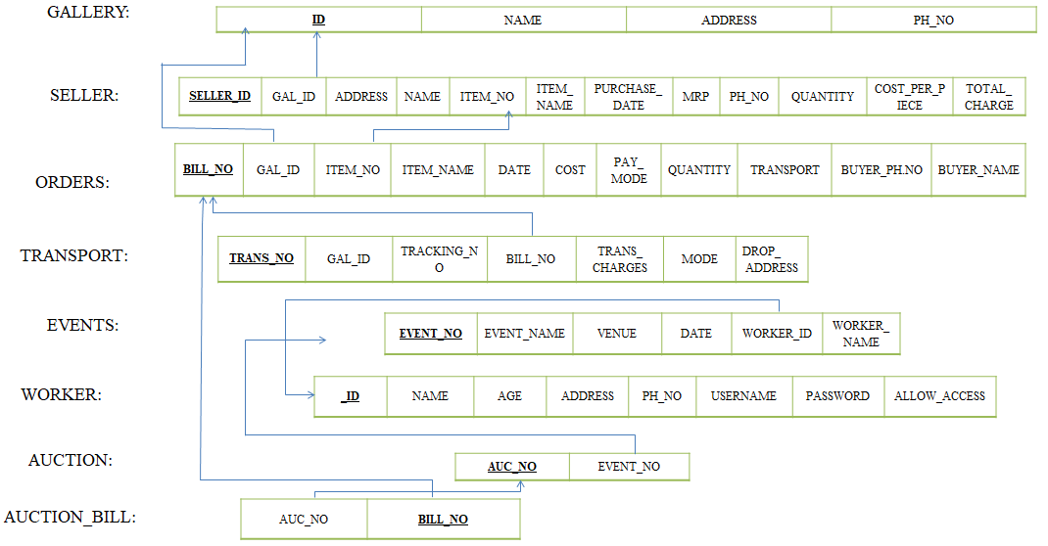**Chapter 3**

**RELATIONAL SCHEMA DIAGRAM**

**Fig.3.1: Relational Schema of Art Gallery**

**3.1 General Constraints**

* **NULL Constraint:** Attributes that are under NOT NULL constraints have to be filled compulsorily. Almost all the attributes in the project are under NOT NULL constraint.
* **Entity Integrity Constraint:** This constraint makes sure that no primary key can have a NULL value assigned to it. The primary keys involved in the project include:

▪ ID

▪ NAME

▪ GAL ID

* **Referential Integrity Constraints:** A table in the back end of the project may have references pointing to an attribute in another table. For example: GAL_ID in the SELLER table refers to ID in GALLERY table. The various tables are also linked with multiple foreign keys which are all set to cascade any update or delete operation on the attribute in the main table. The various Foreign Key attributes are:

▪ GAL_ID

▪ WORKER_ID

▪ BILL_NO

**3.2 Definition of Tables**

1. **GALLERY:** This is a master table that consists of details like id, name, address and phone_no .Here only one gallery is taken into consideration with no branches.
2. **SELLER:** It is a tale of items that are bought by the store from various sellers and artists. It stores details like seller details, MRP, quantity ,cost per piece, item_no etc.
3. **ORDERS:** It is a table that consists of details of the products bought by the customer at the Art Gallery It consists of bill no, gal id, item name, item_no,cost etc.
4. **TRANSPORT:** The gallery facilitates the function of transportation for customers who opt for delivery. It stores details like tracking_id, drop address, bill_no etc.
5. **WORKER:** This table consists of details of the workers working in the gallery. It also has login credentials (username, password) with which the workers can log into the application. It also consists attributes like name, address, phone_no etc.
6. **EVENTS:** It is a table that consists information regarding the events that are conducted by the gallery. It has the following attributes, event_no ,venue ,workers incharge of the event etc.
7. **AUCTION:** Auction is an event which has a different table but links to the events. It consists of event number along with auction no.
8. **AUCTION BILL:** A separate database is maintained for details of the items that are purchased at the auctions.
9. **Stored Procedure:** Various stored procedures are used to insert values into the tables, print the tuples of various tables, delete tuples etc.
10. **VIEW:** the view VIEWALL takes all the information of all the tables holding the gallery attributes and stores them conveniently in one place for the front-end queries to access easily.

**Chapter 4**

**SYSTEM DESIGN**

**4.1 Tables**

**Gallery**

|  |  |  |  |  |
| --- | --- | --- | --- | --- |
| Field | Type | Null | Key | Default |
| Id | numeric(6) | No | primary | Null |
| Name | Varchar(20) | No |  | Null |
| Address | Varchar(50) | No |  | Null |
| Ph_no | numeric(10) | No |  | Null |

**Seller**

|  |  |  |  |  |
| --- | --- | --- | --- | --- |
| Field | Type | Null | Key | Default |
| Seller_id | numeric(5) | No | primary | Null |
| Gal_id | numeric(6) | No |  | Null |
| Address | Varchar(50) | No |  | Null |
| Name | Varchar(20) | No |  | Null |
| Item_no | numeric(3) | No |  | Null |
| Item_name | Varchar(15) | No |  | Null |
| Purchase_Date | date | No |  | Null |
| Phone | numeric(10) | No |  | Null |
| Mrp | int | No |  | Null |
| Total_Charge | int | No |  | Null |
| Quantity | int | No |  | Null |
| Cost_Per_Piece | int | No |  | Null |

**Orders**

|  |  |  |  |  |
| --- | --- | --- | --- | --- |
| Field | Type | Null | Key | Default |
| Bill_no | int | No | primary | Null |
| Gal_id | numeric(6) | No |  | Null |
| Item_no | numeric(3) | No |  | Null |
| Item_name | Varchar(15) | No |  | Null |
| Date | date | No |  | Null |
| Cost | int | No |  | Null |
| Pay_mode | Varchar(10) | No |  | Null |
| Quantity | Int | No |  | Null |
| Transport | bit | No |  | Null |
| Buyer_ph | numeric(10) | No |  | Null |
| Buyer_name | Varchar(20) | No |  | Null |

**Transport**

|  |  |  |  |  |
| --- | --- | --- | --- | --- |
| Field | Type | Null | Key | Default |
| Trans_no | numeric(10) | No | primary | Null |
| Tracking_no | numeric(18) | No |  | Null |
| Bill_no | int | No |  | Null |
| Trans_charges | int | No |  | Null |
| Mode | char | No |  | Null |
| Drop_address | Varchar(50) | No |  | Null |
| Gal_Id | numeric(6) | No |  | Null |

**Event**

|  |  |  |  |  |
| --- | --- | --- | --- | --- |
| Field | Type | Null | Key | Default |
| Event_no | numeric(2) | No | primary | Null |
| Venue | Varchar(50) | No |  | Null |
| Event_date | date | No |  | Null |
| Worker_id | numeric(3) | No |  | Null |
| Worker_name | Varchar(20) | No |  | null |

**Worker**

|  |  |  |  |  |
| --- | --- | --- | --- | --- |
| Field | Type | Null | Key | Default |
| Id | int | No | primary | Null |
| Name | Varchar(20) | No |  | Null |
| Age | int | No |  | Null |
| Address | Varchar(50) | No |  | Null |
| Ph_no | numeric(10) | No |  | Null |
| Username | numeric(6) | Yes |  | Null |
| Password | numeric(8) | Yes |  | Null |
| Allow_Access | numeric(1) | Yes |  | Null |

**Auction**

|  |  |  |  |  |
| --- | --- | --- | --- | --- |
| Field | Type | Null | Key | Default |
| Auc_no | numeric(1) | No | primary | Null |
| Event_no | numeric(2) | No |  | Null |

**Auction bill**

|  |  |  |  |  |
| --- | --- | --- | --- | --- |
| Field | Type | Null | Key | Default |
| Bill_no | int | No | primary | Null |
| Auc_no | numeric(1) | No |  | Null |

**Chapter 5**

**IMPLEMENTATION**

**5.1 Software Used**

C# is a simple, modern, general-purpose, object-oriented programming language developed by Microsoft within its .NET initiative led by Anders Hejlsberg. This tutorial will teach you basic C# programming and will also take you through various advanced concepts related to C# programming language.

Let us look at a simple code that prints the word “hello world”

Using System;

namespaces HelloWorldApplication{

class HelloWorld{

Static Void Main (String[] args){

/*my first program in c#*/

Console.WriteLine (“Hello World”);

Console.ReadKey ();

}

}

}

* The usingkeyword is used to include the Systemnamespace in the program.
* The HelloWorldApplication namespace contains the class HelloWorld.
* The class HelloWorld contains the data and method definitions that your program uses. However, the HelloWorld class has only one methodMain.
* The Main method specifies the statement Console.WriteLine("Hello World");

WriteLine is a method of the Console class defined in the System namespace. This statement causes the message "Hello, World!" to be displayed on the screen.

* The last line Console.ReadKey **();** is for the VS.NET Users. This makes the program wait for a key press and it prevents the screen from running and closing quickly when the program is launched from Visual Studio .NET.

SQLite is a small, fast and embeddable database where the database engine and the interface are combined into a single library. It also has the ability to store all the data in a single file. It is a software library that implements a self-contained, serverless, zero-configuration, transactional SQL database engine. SQLite is the most widely deployed SQL database engine in the world. All the SQLite statements start with any of the keywords like select, create, update, insert, delete, alter, drop etc., and all the statements end with a semicolon (;).

**5.2 Snapshots**

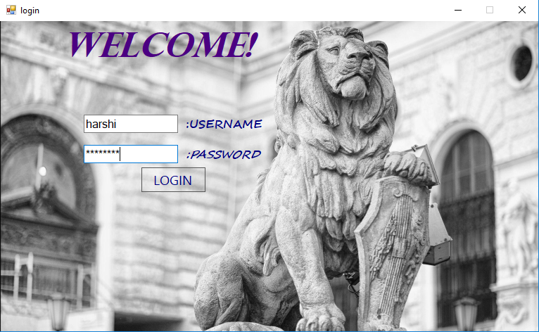

**Fig.5.1: Login form**

Fig.5.1 shows the login form of the Art Gallery application.

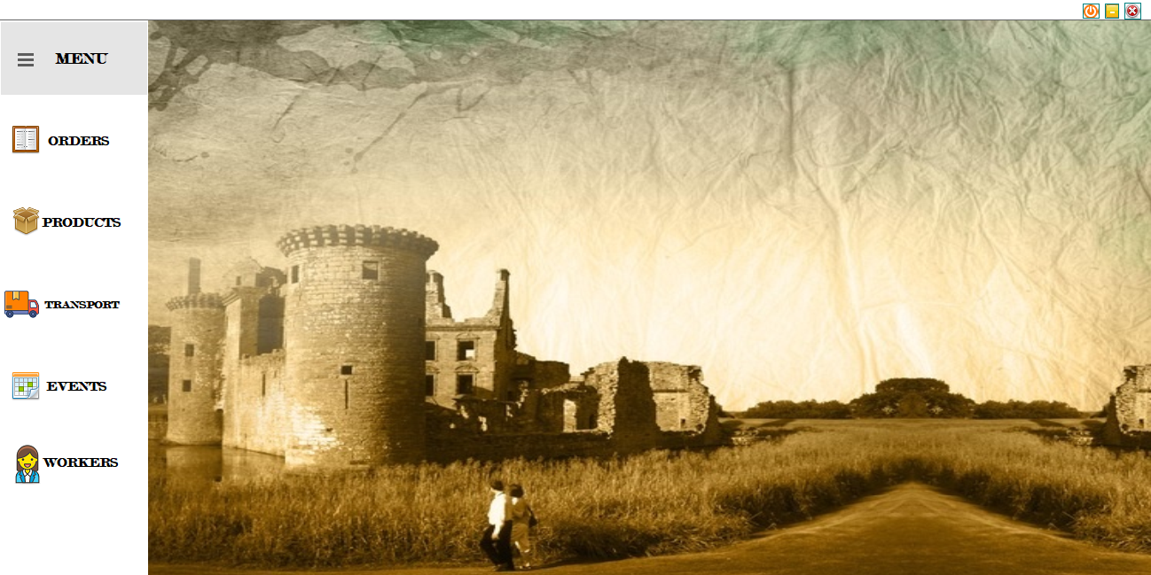

**Fig.5.2: Main Menu**

Fig.5.2 shows the main menu of the application.

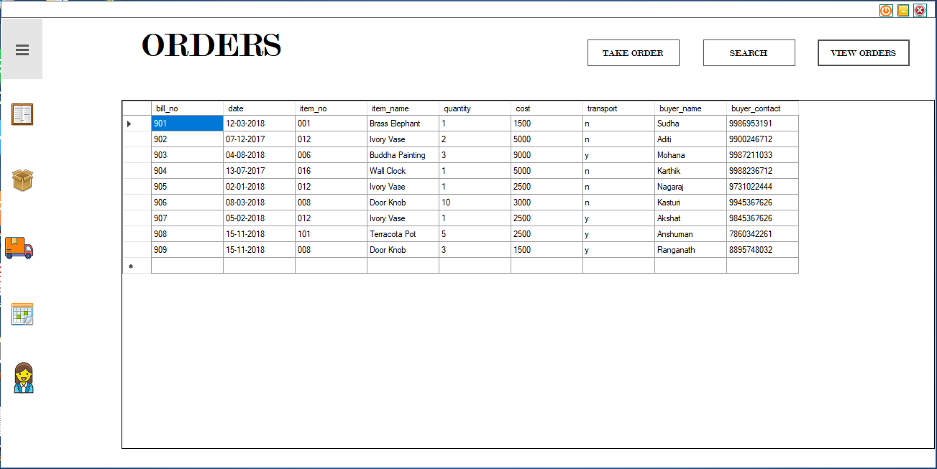

**Fig.5.3: View Orders**

Fig.5.3 shows the detailed list of orders billed at the gallery.

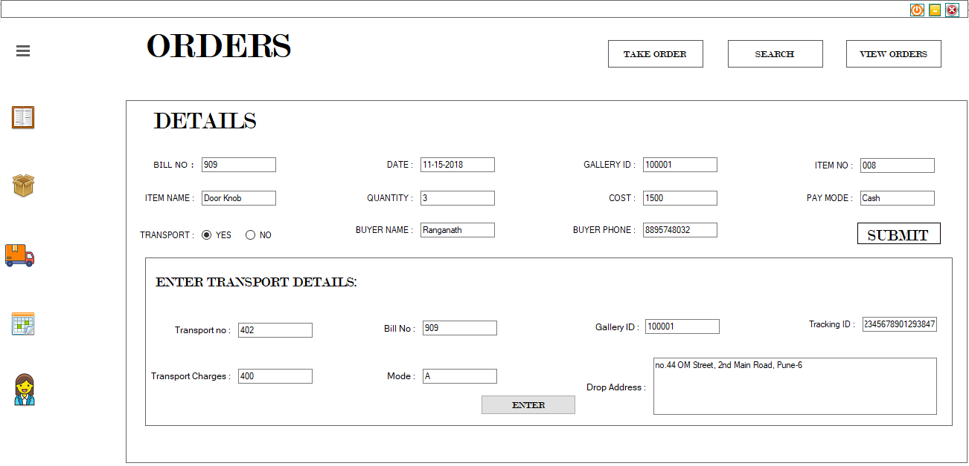

**Fig.5.4: Take Orders**

Fig.5.4 shows the form to take the orders along with the transport requirements form.

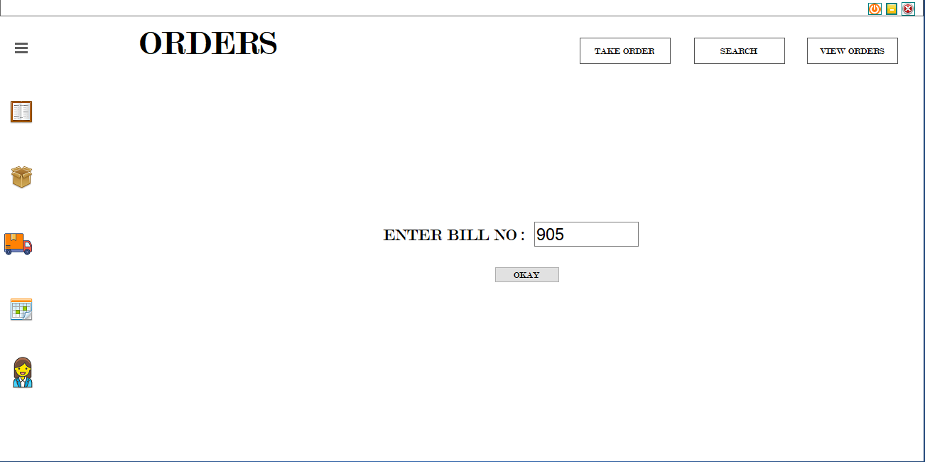

**Fig.5.5: Search Orders**

Fig.5.5 shows the page to enter bill number in order to search for a particular bill.

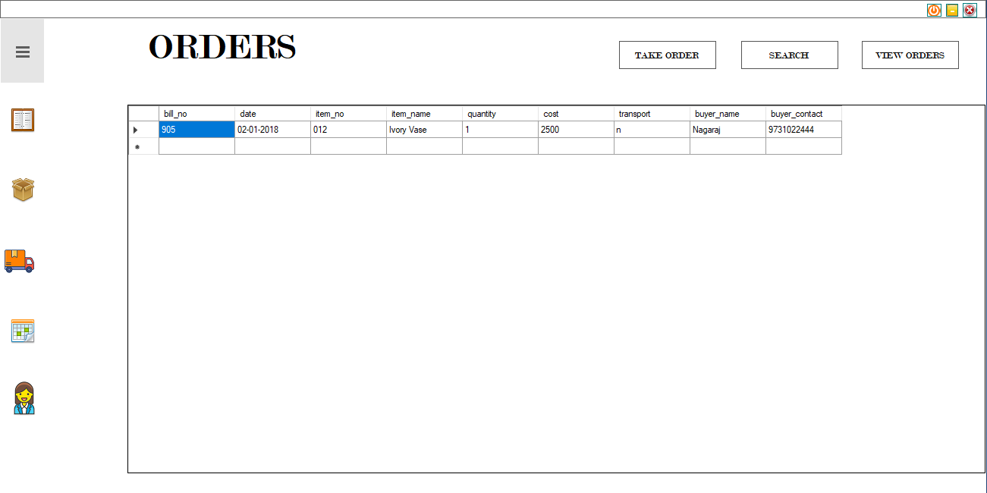

**Fig.5.6: Show Search Orders**

Fig.5.6 shows the particulars of the searched bill.

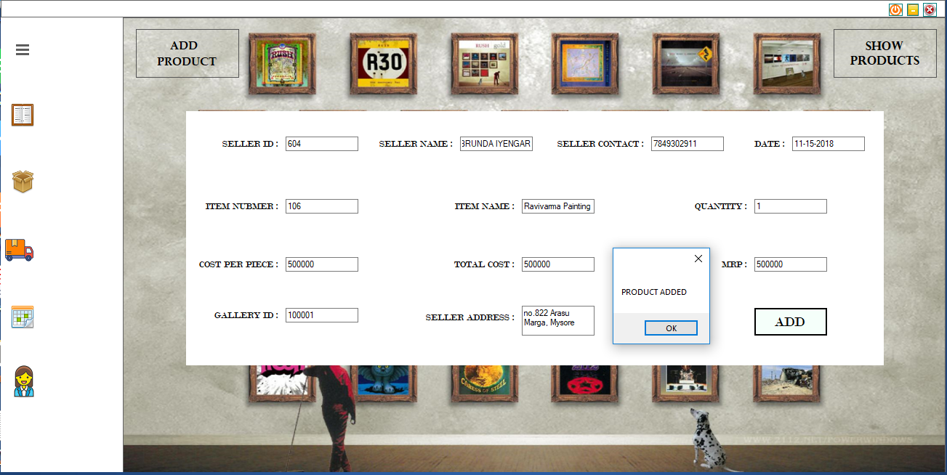

**Fig.5.7: Add Product**

Fg.5.7 show the form to add new products bought by the gallery.

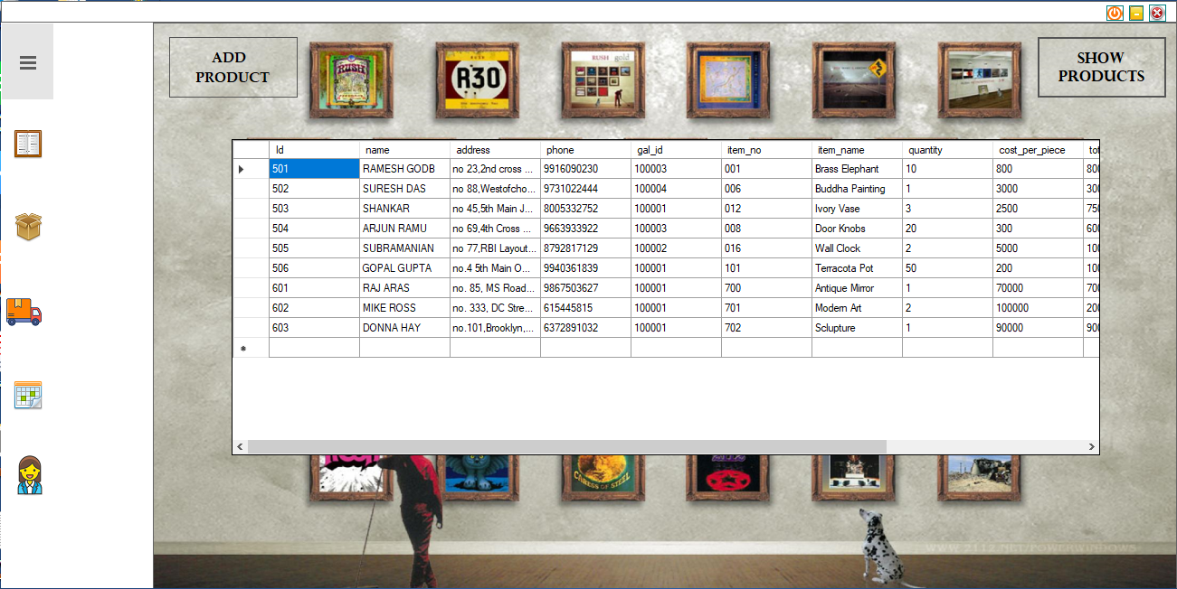

**Fig.5.8: List Of Products**

Fig.5.8 show the list of products in ought by the gallery along with their seller’s details.

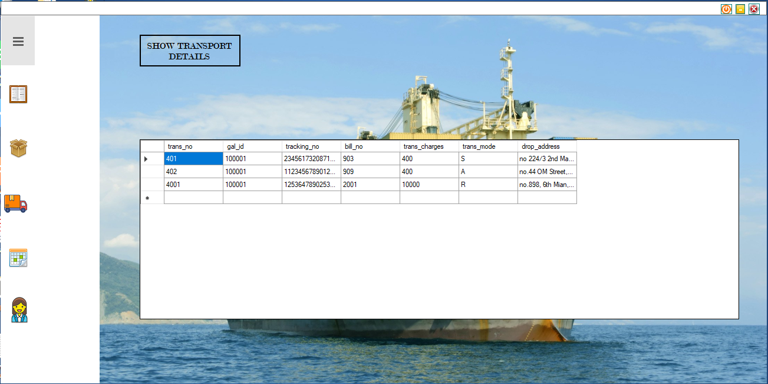

**Fig.5.9: Transport Details**

Fig.5.9 show the list of shipments.

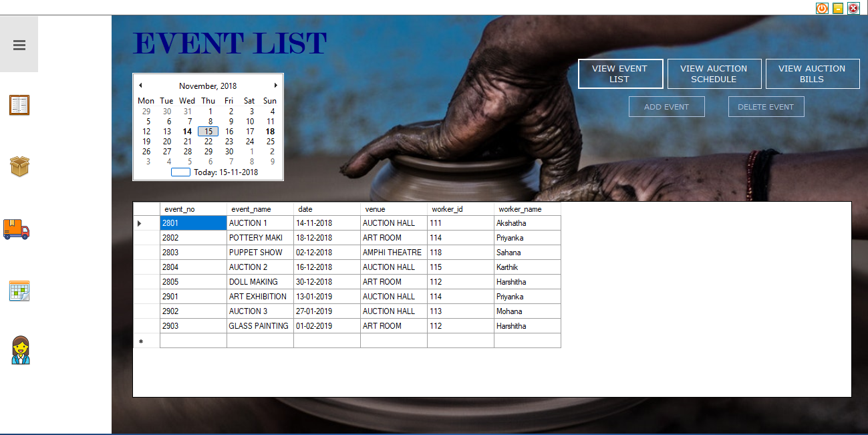

**Fig.5.10: Event List**

Fig.5.10 show the list of events conducted by the Art Gallery.

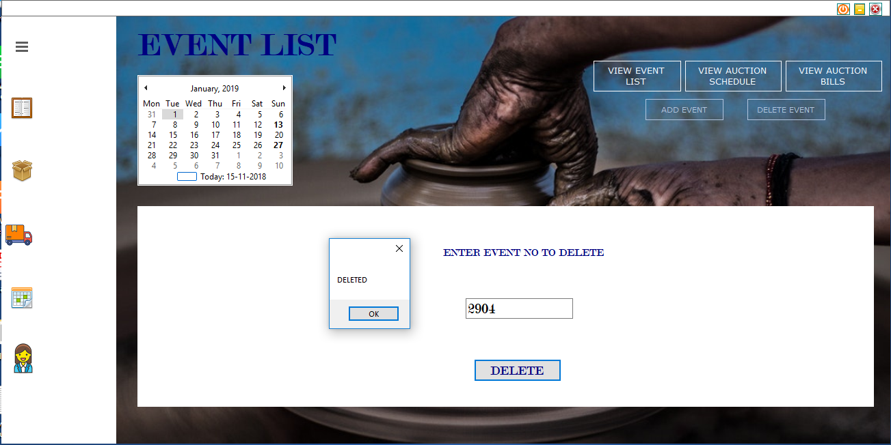

**Fig.5.11: Delete Event**

Fig.5.11 show the deletion of an event.

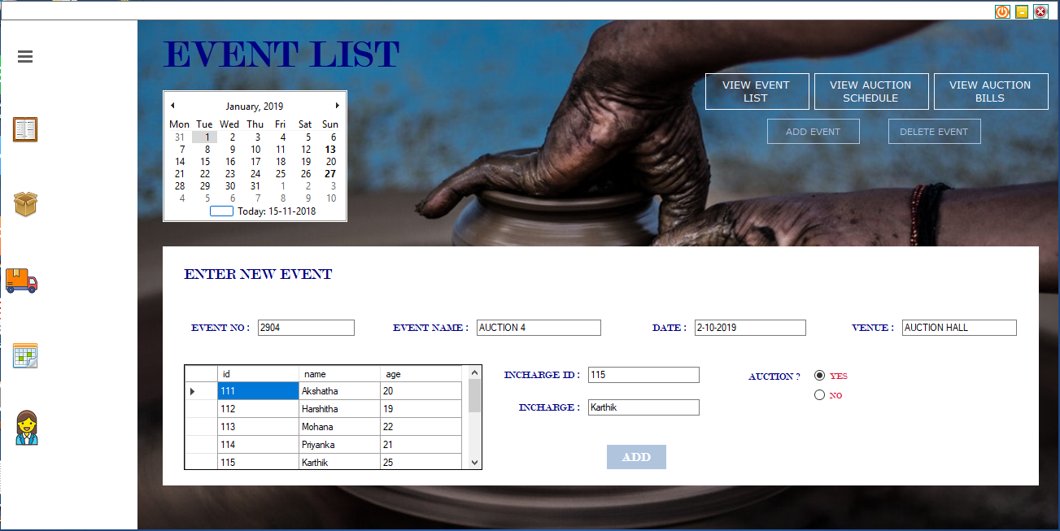

**Fig.5.12: New Event**

Fig.5.12 shows the addition of a new event.

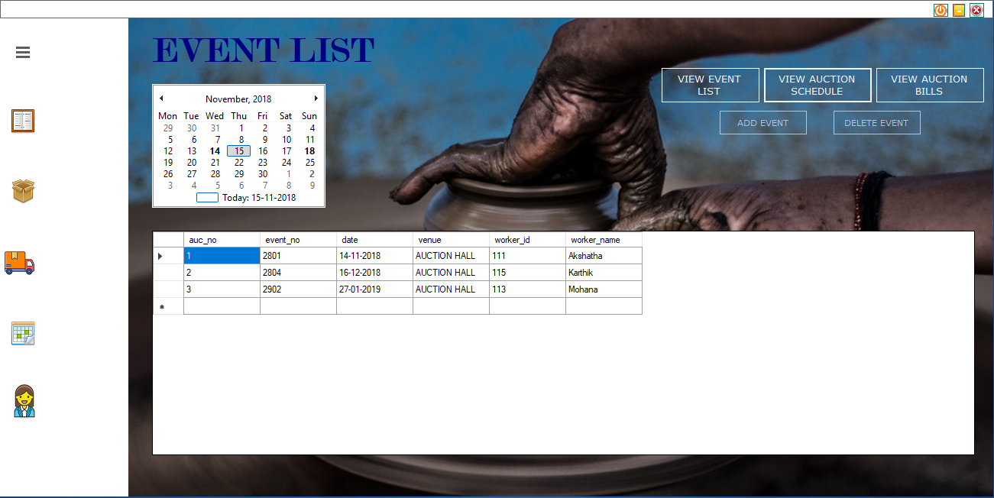

**Fig.5.13: Auction List**

Fig.5.13 shows the list of auctions held/to be held.

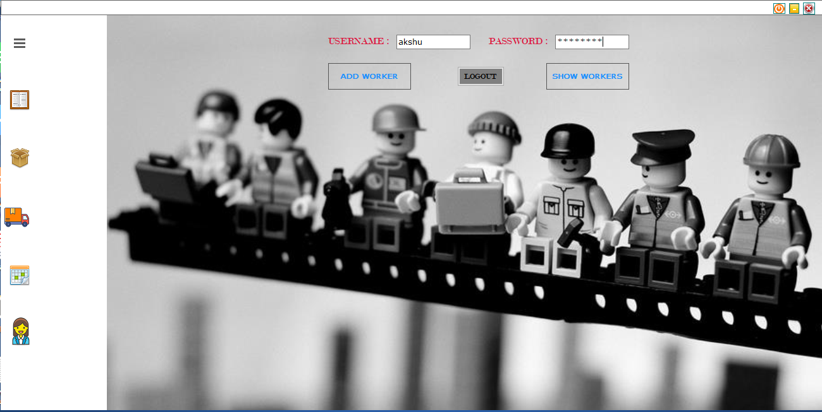

**Fig.5.14: Worker data login**

Fig.5.14 show the login page to access workers’ data.

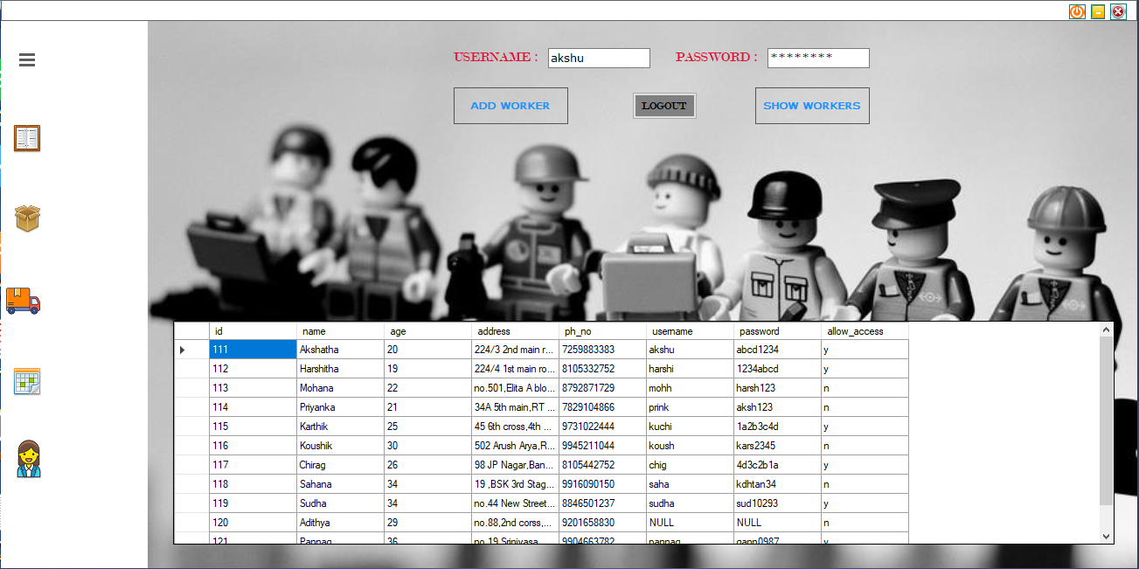

**Fig.5.15: Worker List**

Fig.5.15 shows details of the workers.

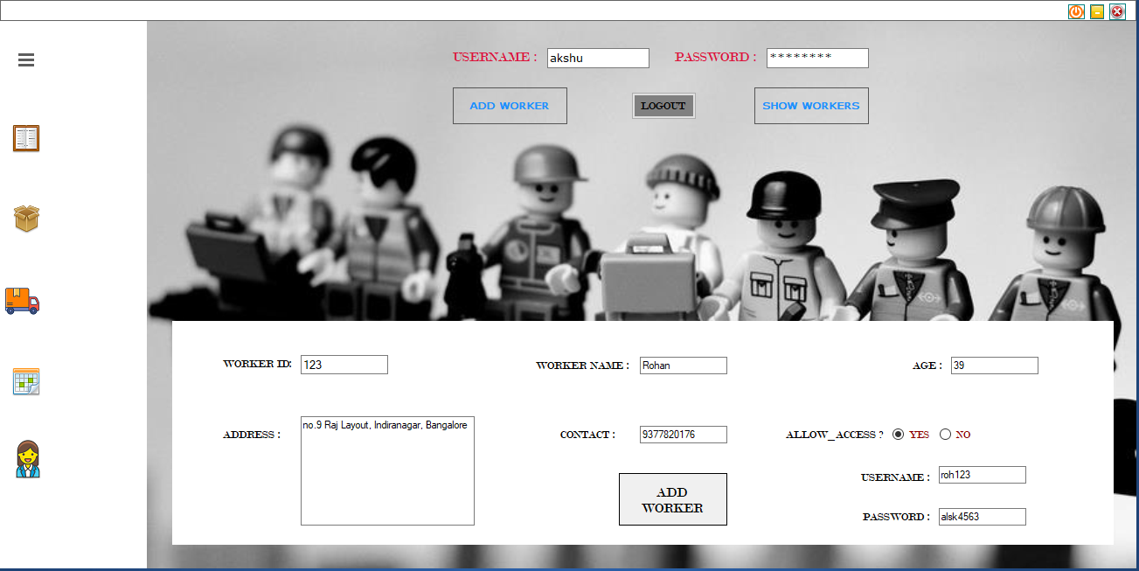

**Fig.5.16: Add Worker**

Fig.5.16 shows the form to add a new worker.

**Chapter 6**

**APPLICATIONS**

* Managing sales in any retail store
* Keeping a track of workers
* Database of events conducted
* List of products available at the store

The idea is to expand the application to as many genres of store as possible from a small grocery store to a large museum.

**Chapter 7**

**CONCLUSION**

Our project is a an attempt to make the structure and working of any retail store simpler and user-friendly. In this scenario, all the undertakings of an Art Gallery are achieved in a constructive manner.

Give the right guidance and support, we hope to enhance the it’s applications and availability.

**Chapter 8**

**FUTURE ENHANCEMENTS**

* Printing generated bills
* Advanced software for art gallery including more facilities like market values of products, connections to artists and vendors across the world
* Hosting the platform on online servers
* Integrate multiple load balances to distribute the loads of the system
* Create the master and slave database structure to reduce the overload of the database queries
* Implement the backup mechanism for taking backup of codebase and database on regular basis on different servers
* E-Commerce website

**REFERENCES**

1. Raghu Ramakrishnan and Johannes Gehrke, Database Management Systems,

McGREW HILL, 3rd Edition

1. Ramez Elmasri and Shamkant B. Navathe, Fundamentals of Database Systems, Pearson, 7th Edition
2. Herbert Schildt, Java: The Complete Reference, McGRAW HILL, 7th Edition
3. [www.stackoverflow.com](http://www.stackoverflow.com)
4. [www.mysql.com/doc](http://www.mysql.com/doc)
5. <https://docs.microsoft.com>
6. https://www.geeksforgeeks.org